**Install GUIDE**

**Instructions to build server**

1. Install Visual Studio 2022 and the .NET SDK version 6.0 or later. You can download it from the official Microsoft website.
2. After installing Visual Studio 2022
3. Click double click folder Source
   * Click double file PostOfficeOnline.sln
   * Open project PosOffice.API
   * Configure database connection in file appsettings.json in solution



* + Here you need to reconfigure the uid and pwd sqlserver database connection information
* “server=...;” is your Server Properties name in SSMS (SQL Server Management Studio) 
  + After the configuration is complete, you need to click on Tools -> Nuget Package Manage -> Package Manage Console

* Belows Taskbar you need to choose Default Project: PossOffice.API
* And type command: Add-Migration InitialDBA screenshot of a computer

  Description automatically generated

* Build succeed. You type command: Update-Database

Like this is complete the database initialization

**Instructions to build Client, Admin**

1. Right click on Solution ‘PostOfficeOnline’. Choose Multiple startup projects -> Action ->Start (2 Project)

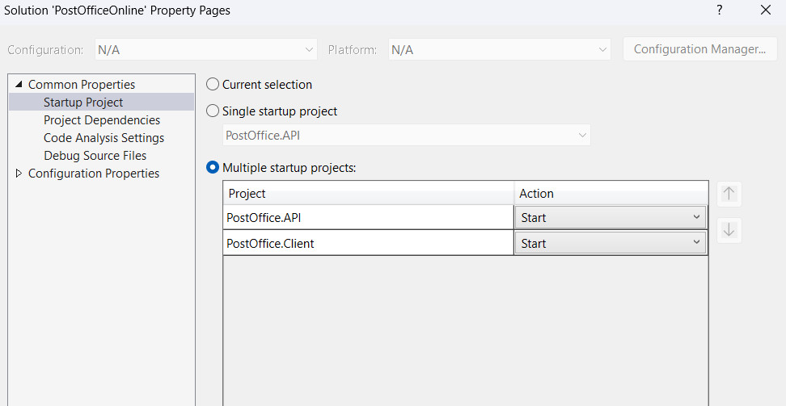

1. **Start client project**

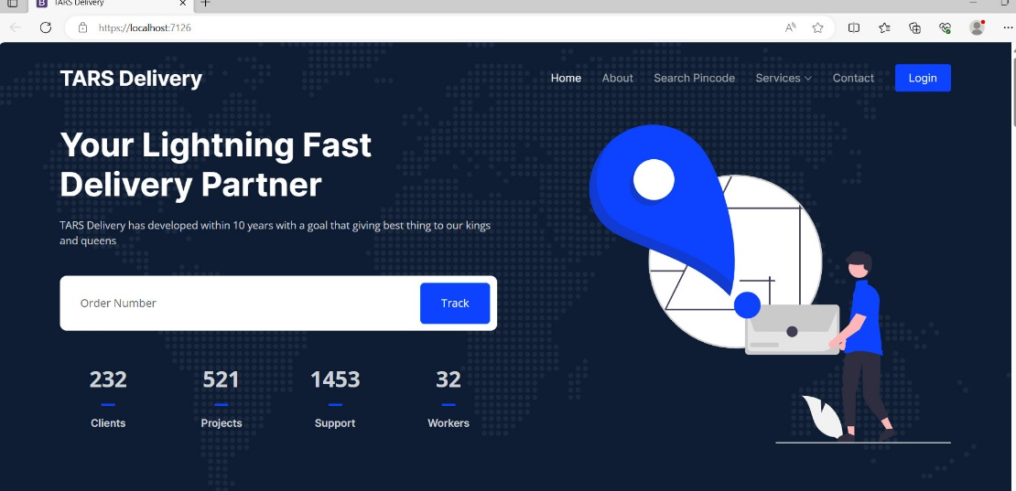

* 1. On Browser and choose **Login**
  2. We have an account available for customer :

Email: [**hoanguyen@gmail.com**](mailto:hoanguyen@gmail.com)

Pass: **Hoa.13**

* 1. In anothercase, you can create a new account.
  2. This is the project folder on my machine. \PostOfficeProject\Source\Client\Areas\Client

1. **Start Admin**
   1. Next you need login Admin account
   2. Access the admin page: <http://localhost:7126>

* 1. You login by available account

Email: **onlinepostofficegroup4@gmail.com**

Pass: **aptech.123**

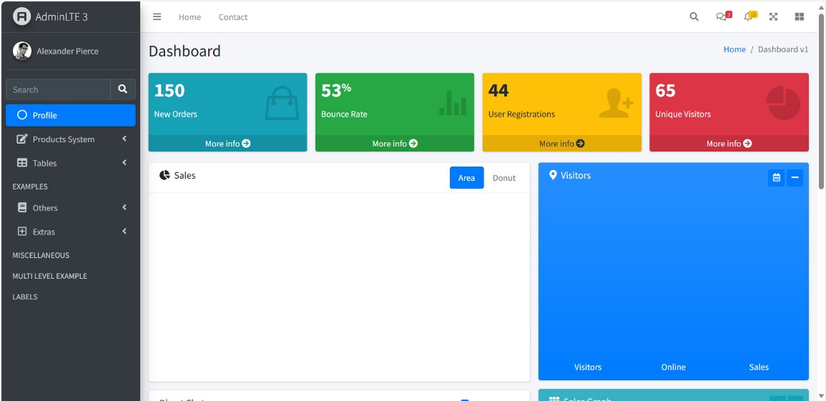

* 1. This is the project folder on my machine. PostOfficeProject\Source\Client\Areas\Admin